COSC 4377 – Networking - Kevin B Long

# interlocking-uh-m-186.eps

# Homework #1

Due 11:59pm, Monday, 5 February, 2017

Multiple submissions accepted.

1. Traceroutes

* Finding sites to traceroute can be tough. UH seems to block many, as does AT&T’s U-Verse service.
* The last line of a successful traceroute will include the name of the target site. Example:
* The last line of an unsuccessful traceroute will usually be asterisks. Either your network provider or the other end is blocking them.
* Examine your traceroute carefully -- if your traceroutes start spewing out asterisks before you ever leave your local network (you may see several lines but they seem to be uh-related, for example, or at the least, it’s not clear they’re some other ISP), then your local network is probably blocking the traceroute. Bypass this by installing a VPN or switching to another network. Most VPN services let you try things out for free. I found a list here: <https://www.vpnranks.com/best-vpn-reviews/>. VPN services will tunnel your traffic to their location and you’ll be tracerouting from there. They usually don’t block anything.
* If you examine your traceroute carefully, however, and believe it’s the destination or someplace on the way that’s blocking you, then try tracerouting to different sites. I had lots of luck tracerouting to Rice University from within UH, and terrible luck tracerouting to UH from within UH. Ironic, but not at all uncommon.
* The point is that you need to be able to do traceroutes for the homework. If you can’t do it yourself, ask a friend to do it for you on their computer and send the results to you, maybe from their work, where sites are usually more open or from another part of the world, etc. The source and destination must be on different networks, especially topographically distant ones.
* As a last resort, you may traceroute from a tools web site, like here: <https://mxtoolbox.com/NetworkTools.aspx> (search for Trace). It’s a good site to know anyway.
* Use traceroute to discover which routers are in a path between your computer and some web server, ideally an educational institution.
* If you don’t know how to run a traceroute, these sites should help. For windows:

<https://support247webs.com/windows-traceroute/>

On a Mac, there are two methods:

<http://appletoolbox.com/2015/10/how-to-run-a-traceroute-in-mac-os-x/>

<http://appletoolbox.com/2015/10/how-to-run-a-traceroute-in-mac-os-x/>

On a Mac, the two methods don’t always produce the same results. Try both, and use the one that gives you a longer list of routers in your traceroute.

So here’s the task:

What site did you traceroute?

**https://github.com/**

(2x9 pts)

1. An acceptable traceroute is one that completes successfully. Copy and paste your results below

.

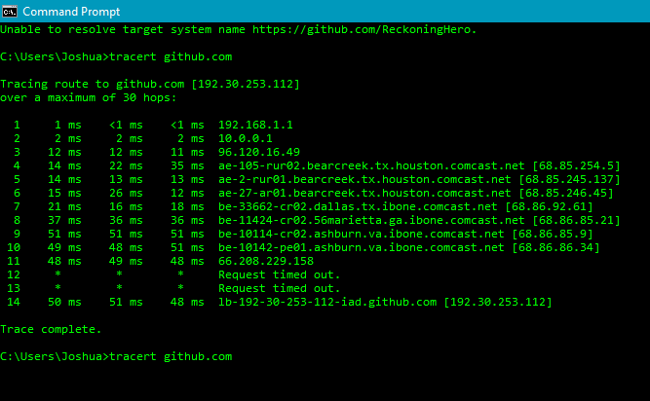

1. Sometimes sites use an alias for the real name of their server. According to the first row of the traceroute, what’s the actual name of the host?

**Github.com [192.30.253.112]**

1. How many hops/routers were involved?

**30**

1. Do any of the steps report taking longer to reach than the final destination? Many traceroutes do, such as the one below.

How is this possible?  **Different packets, each router makes its own decisions on the speed to implement any trace, bottleneck of the connection**

1. The routers and hosts you are reaching have IP addresses. Pick two from your traceroute, write them down and report who owns each. Use <https://mxtoolbox.com/arin.aspx>.

**192.168.1.1 --> Internet Assigned Numbers Authority (IANA)**

**96.120.16.49--> Comcast Cable Communications, LLC (CCCS)**

1. Often we find that we have been assigned an IP address that starts with 10. For example, I am assigned “10.137.64.1” by AT&T at home. Search the WHOIS database at [www.arin.net](http://www.arin.net) and report the Name of the network:

**PRIVATE-ADDRESS-ABLK-RFC1918-IANA-RESERVED**

1. What is the Name of the Organization that owns the address?

**Internet Assigned Numbers Authority (IANA)**

1. Back to your site from (a). Use <https://www.bitcatcha.com/> to report how long the web page takes to load.

**28 ms**

1. Does it appear that more time is spent traversing the network or loading the page? Remember that web site response time includes network traversal.

**It appears that it spends more time traversing the network than loading the page**

1. (10 pts) Complete the first Wireshark lab in the Google Drive folder “Wireshark Labs”. The lab is named “01 Wireshark_Intro_v7.0”. Despite being an introduction, there are still answers to turn in.
2. **3 Protocols: TCP, UDP, HTTP**
3. **40 MINS**
4. **192.168.1.101**

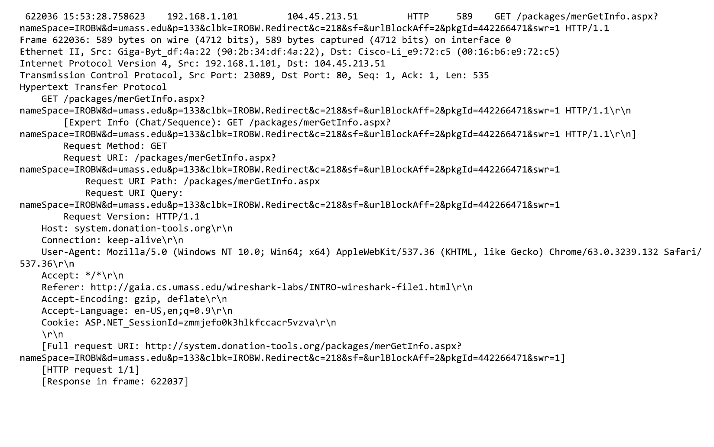

1. (5 pts) What are the five layers in the Internet protocol stack? What are the principal responsibilities of each of these layers?

**Application**

* **Protocols such as HTTP,SMTP, and FTP**
* **Use transport layer protocols for establishing host –host connection**

**Transport**

* **Responsible for client and server of application**
* **Uses two protocols for transporting messages such as TCP and UDP.**

**Network**

* **Sends packets from one host to destination.**
* **Routing protocols between source and destination**

**Data Link**

* **Responsible for link-level communication**
* **Sends entire frames from one network element to the next one**

**Physical**

* **Moves individual bits of frames to the next**
* **Provides physical media**

1. (5x2 pts) What is the unit of information called that each layer produces in the TCP/IP model?
2. **Application layer: login host**
3. **Transport layer: TCP segment**
4. **Network layer: IP datagrams**
5. **Data Link layer: cyclic redundancy check (CRC)**
6. **Physical layer: frame**
7. (6x2 pts) Not all devices process all layers all the time.
   1. Which layers in the Internet protocol stack does a router process?

**Routers process network, link and physical layers.**

* 1. Which layers does a link-layer switch process?

**Link layer switches process link and physical layers.**

* 1. Which layers does a host process?

**Host processes all five layers of the Internet protocol.**

* 1. If we have a device that receives an electrical signal on a twisted pair cable, filters off high frequencies to remove noise, and amplifies the signal strength, but is completely passive and otherwise knows of the meanings of the signals, at what layer does it operate?

**Physical layer**

* 1. A router offers a way for an administrator to log in and manage the device. Code to run a secure shell has been added to the router, and the administrator can log into the router remotely and change the configuration. This is an example of the router running what layers of the stack?

**Application, Transport, and Network layers**

* 1. We want to build a device that runs only the application layer. Is this possible? **No, it requires a physical layer to physically build a device.**

1. (2x3 pts) Equation 1.1 gives a formula for the end-to-end delay of sending one packet of length L over N links of transmission rate R which ignores propagation delay:

$$d_{end-to-end}=N\frac{L}{R}$$

Consider a network 2 two hosts, 2 switches and thus 3 links, and 10 packets.

At time 0, all 10 packets are at Host A.

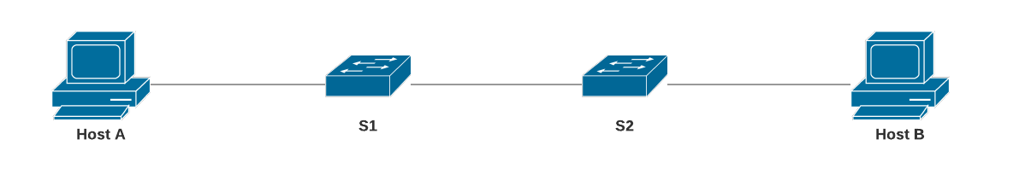

L/R is the transmission delay, so we have to wait that amount of time for a packet to leave a device.

Therefore, at time 1*L/R, one packet has moved to the first switch, and 9 packets remain at Host A. At time 2*L/R packets have advanced one position, but none have reached Host B yet:



Not until time 3*L/R does a packet arrive at Host B. (10-1) packets remain in transit or awaiting transmission.



The 2nd packet is at S2, only one transmission away from Host B, and after it arrives, the 3rd packet will be at S2, one transmission away. So after the first packet arrived at Host B, we need 9 more rounds of L/R to bring the remaining packets to Host B.

1. Can you generalize the equation to 2 hosts, N links (and so N-1 network devices), and P packets?

**1 x d1 = [9(L/R)] x P**

1. If we add propagation delay *dprop* to each link, can you generalize the equation further?

**N((PD + TD) x P**

1. (2x3 pts) Review the car-caravan analogy in Section 1.4. Assume a propagation speed of 100 km/hour.
2. Suppose the caravan travels 150 km, beginning in front of one tollbooth, passing through a second tollbooth, and finishing just after a third tollbooth. What is the end-to-end delay? Hint: assume tollbooths are 75km apart. Then calculate how many seconds a tollbooth needs to service one car. Then you can work out how many seconds to service all cars, and how long each car’s propagation delay is for the 75km before arriving at the second tollbooth. How long before they’re all in front of the second tollbooth? You repeat the whole process again from the second to the third tollbooth, where there is a servicing delay once again. That’s your total.

**Propagation speed = 100 km/hr**

**Time to take to reach a single car = 12 seconds**

**Total distance/Propagation speed = (150km)/(100km/hr) = 1.5 hrs 🡪 Propagation delay**

**To reach up to 10 cars: 10 * 12 = 120 seconds = 2mins 🡪 Transmission delay**

**End to end delay = N(PD + TD)**

**End of end delay = 1 hr and 36 mins**

**Transmission delay = (150km/)(100km/hr)**

1. Repeat (a), now assuming that there are 12 cars in the caravan instead of ten.

**Num of cars = 12**

**Total distance = 150**

**Total distance/Propagation speed = (150km)/(100km/hr) = 1.5 hrs 🡪 Propagation delay**

**12 cars = 12 x 12 = 144 seconds**

**144 * 3 tollbooths = 432 seconds 🡪 7.2 mins**

**7 mins and 12 secs + 1hr and 30 mins = 1 hr 37 min 12 secs 🡪 End to End delay**

1. (8x2 pts)Consider two hosts, A and B, connected by a single link of rate R bps. Suppose that the two hosts are separated by m meters, and suppose the propagation speed along the link is s meters/sec. Host A is to send a packet of size L bits to Host B.
2. Express the propagation delay, *dprop*, in terms of *m*and *s*.

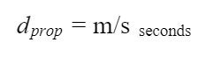

d

1. Determine the transmission time of the packet, *dtrans*, in terms of *L* and *R*.

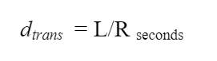

1. Ignoring processing and queuing delays, obtain an expression for the end-to-end delay.



1. Suppose Host **A** begins to transmit the packet at time *t* = 0. At time *t* = *dtrans*, where is the last bit of the packet?

**The last bit will be leaving the Host A packet.**

1. Suppose *dprop* is greater than *dtrans*. At time *t* = *dtrans*, where is the first bit of the packet?

The first bit is in the link and has not reached Host B

1. Suppose *dprop* is less than *dtrans*. At time *t* = *dtrans*, where is the first bit of the packet?

**The first bit is in the link and has not reached Host B**

1. After how much time will the first bit be delivered to the waiting application on Host B?
2. Suppose *s* = 2.5 x 108*m/s*, *L* = 200 bits, and *R* = 56 kbps. Find the distance *m* so that *dprop* equals *dtrans*. Round to the nearest kilometer.

**((2.5 x 10^8 m/s)) + (200 bits/56,000 kbps) 🡪 8928571.43 🡪8929 km**

1. (2x3 pts) Consider a packet of length *L* which begins at end system A and travels over *l* links to a destination end system B. These three links are connected by (*l-1*) routers. Let *di*, *si*, and *Ri* denote the length, propagation speed, and the transmission rate of link *i*, for *i* = 1, 2, 3. Each router adds *dproc* processing delay, and *dqueue* queueing delay.
2. What is the total end-to-end delay *dt* for the packet? **0.087 seconds**
3. Suppose now there are 2 routers and 3 links. The packet is 1,500 bytes, the propagation speed on all links is 2.5 x 108 m/s, the transmission rates of all the links are 2 Mbps, the router processing delay is 1ms for processing, 2ms for queueing, the length of the first link is 5,000 km, the length of the second link is 4,000 km and the last 1,000km. For these values, what is the end-to-end delay?

**dend-to-end= N(dproc + dtrans + dprop)  
= N(dproc+(L/Ri)+ (di meters/si sec))**

**Given the following:  
N=3  
L= 1,500 bytes  
si= 2.5*10^8 m/s on all links  
Ri= 2 Mbps  
dproc= 3 msec  
d1= 5,000 km  
d2= 4,000 km  
d3= 1,000 km  
  
  
i=1, N(dproc+(L/R1)+ (d1 meters/s1 m/sec))  
=3(0.003 sec+(1,500*8 bits/2,000,000 bits/sec)+ (5,000,000 m/2.5*10^8 m/sec))  
=0.087 seconds**

**i=2; dend-to-end= N(dproc+(L/R2)+(d2 meters/s2 m/sec))  
dend-to-end= 3(0.003 sec+(1,500*8 bits/2,000,000 bits/sec)+ (4,000,000 m/2.5*10^8 m/sec))  
=0.075 seconds**

**i=3; dend-to-end= N(dproc+(L/R3)+(d3 meters/s3 m/sec))  
dend-to-end= 3(0.003 sec+(1,500*8 bits/2,000,000 bits/sec)+ (1,000,000 m/2.5*10^8 m/sec))  
=0.039 seconds**

**Add together:  
0.087 sec+0.075 sec+0.039 sec= 0.201 sec**

1. (3 pts) In the above problem, suppose all transmission rates *Ri* = *R*, and *dqueue = dproc* = 0. Further suppose the packet switch does not store-and-forward packets but instead immediately transmits each bit it receives before waiting for the entire packet to arrive. What is the end-to-end delay?

**Transmission Rate = R1=R2=R3**

**Propagation Delay = 0**

**1500 bytes = 1500 x 8 bits**

**Propagation Speed = 2.5 x 10^8 m/s**

**The End System Requires to transmit the packet onto the link =L/R = (1500×8)/(2×10^6)= 6 ms**

**Length of the First Link = 5000 km**

**The Packet propagates over the first link delay = 5000×10^3  /  2.5×10^8 = 20 ms**

**Length of Second link = 4000 km**

**The Packet propagates over the second link delay = 4000×10^3  /  2.5×10^8 = 16 ms**

**Length of Third link = 1000 km**

**The Packet propagates over the third link delay = 1000×10^3  /  2.5×10^8 = 4 ms**

**The End to End delay = 6+20+16+4 = 46 ms**

1. (3 pts) Consider a router buffer preceding an outbound link. Let *N* denote the average number of packets in the buffer plus the packet being transmitted. Let *a* denote the rate of packets arriving at the link. Let *d* denote the average total delay (processing, queueing, and transmission delay) per packet. Little’s formula is

$$N = a × d$$

Suppose that on average, the buffer contains 10 packets, and the average packet queuing delay is 10 msec. The link’s transmission rate is 100 packets/sec.

Using Little’s formula, what is the average packet arrival rate, assuming there is no packet loss?

**N = a * d 🡪 A = N/d**

**Average number of packets N = 10**

**Rate of packets a:**

**Link transmission rate l = 100 packets/sec = 1 packet/.01 sec**

**Average total delay d = l + q =0.2 sec**

**Queueing delay q = 10 msec = .01 sec**

**A = 10 packets/(.02 sec)🡪 500 packets/sec**

1. (5 pts) A packet arrives at a router which makes a decision about the next link over which it is to travel. There is a buffer for that link which currently holds 4 packets. There is one packet that is 50% transmitted. Assume packets are all 1,500 bytes, and the link has a bandwidth of 2 Mbps.
2. How long will this packet have to wait before its transmission can begin? This is the queueing delay.

**The number of packets in the buffer above is: 4  
   Each packet has 1500 bytes**

**Additionally, one packet is 50% transmitted   
   Link speed = 2 Mbps**

**Wait time = Complete transmission of current packet + 3 more packets  
             = (750 * 8)/(2*10^6) + 3 * (1500 * 8)/(2*10^6)  
             =   42000/(2*10^6)  
             =   21 * 10^-3  
             =   21 ms**

**Thus, 21 ms will be the time this packet have to wait before its transmission can begin.**

1. Can you generalize the equation for queueing delay for a particular queue if arriving packets have length *L bits*, the transmission rate is *R*, *x* bits of the currently-being-transmitted packet have been transmitted, and *n* packets are already in the buffer (queue)?

**Wait/Buffer Time = (L-x)/R + n * (L/R)**